Image | 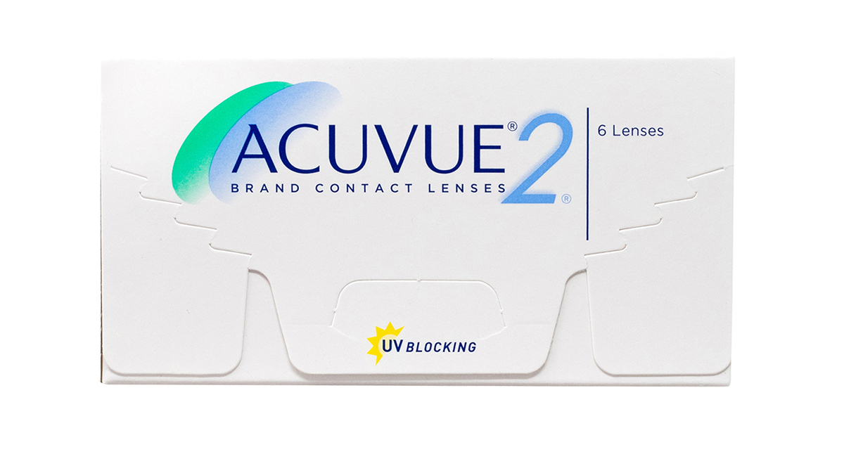
Brand | GUCCI
Model Name | acuvue-25
Price | RS 1699
PRODUCT DETAILS

